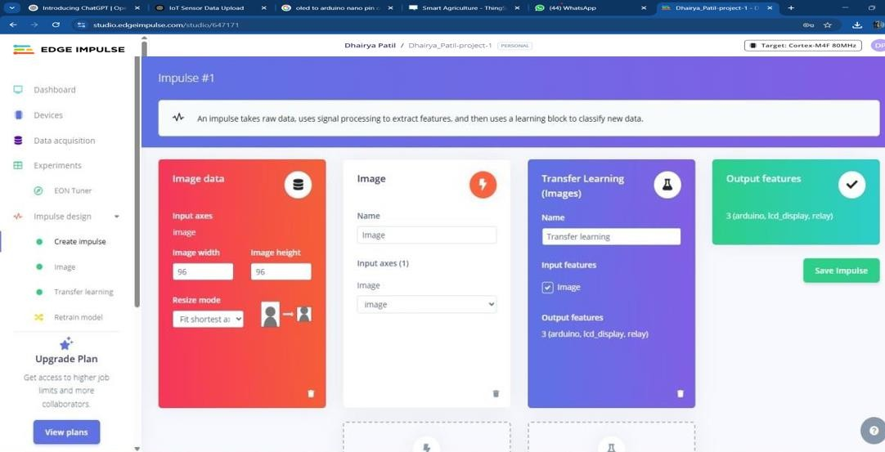**Name:** Dhairya Patil **Class:** TY-15 (Batch C) **Roll Number:** 2223929

ECL Experiment 9

## Introduction

**The Object Detection using Camera on Edge Computing Devices**

**Objective:** Build a project to detect an object using Edge Computing

**Tasks:**

* Generate the dataset for customized object
* Configure Edge Impulse for Object Detection
* Building and Training a Model
* Deploy on Edge Computing Device

## Introduction

Edge Impulse is a development platform for machine learning on edge devices, targeted at developers who want to create intelligent device solutions. The " Camera "sensor reading equivalent in Edge Impulse would typically involve creating a simple machine learning model that can run on an edge device, like classifying sensor data or recognizing a basic pattern.

## Materials Required

* Nano BLE Sense Board

## Theory

GPIO (General Purpose Input/Output) pins on the Raspberry Pi are used for interfacing with other electronic components. BCM numbering refers to the pin numbers in the Broadcom SOC channel, which is a more consistent way to refer to the GPIO pins across different versions of the

Here’s a high-level overview of steps you'd follow to create a "Hello World" project on Edge Impulse:

**Steps to Configure the Edge Impulse:**

1. Create an Account and New Project:

* Sign up for an Edge Impulse account.
* Create a new project from the dashboard.

1. Connect a Device:

* You can use a supported development board or your smartphone as a sensor device.
* Follow the instructions to connect your device to your Edge Impulse project.

1. Collect Data:

* Use the Edge Impulse mobile app or the Web interface to collect data from the onboard sensors.
* For a "Hello World" project, you could collect accelerometer data, for instance.

1. Create an Impulse:

* Go to the 'Create impulse' page.
* Add a processing block (e.g., time-series data) and a learning block (e.g., classification).
* Save the impulse, which defines the machine learning pipeline.

1. Design a Neural Network:

* Navigate to the 'NN Classifier' under the 'Learning blocks'.
* Design a simple neural network. Edge Impulse provides a default architecture that works well for most basic tasks.

1. Train the Model:

* Click on the 'Start training' button to train your machine learning model with the collected data.

1. Test the Model:

* Once the model is trained, you can test its performance with new data in the 'Model Testing' tab.

1. Deploy the Model:

* Go to the 'Deployment' tab.
* Select the deployment method that suits your edge device (e.g., Arduino library, WebAssembly, container, etc.).
* Follow the instructions to deploy the model to your device.

1. Run Inference:

* With the model deployed, run inference on the edge device to see it classifying data in real-time.

1. Monitor:

* You can monitor the performance of your device through the Edge Impulse studio.

1. 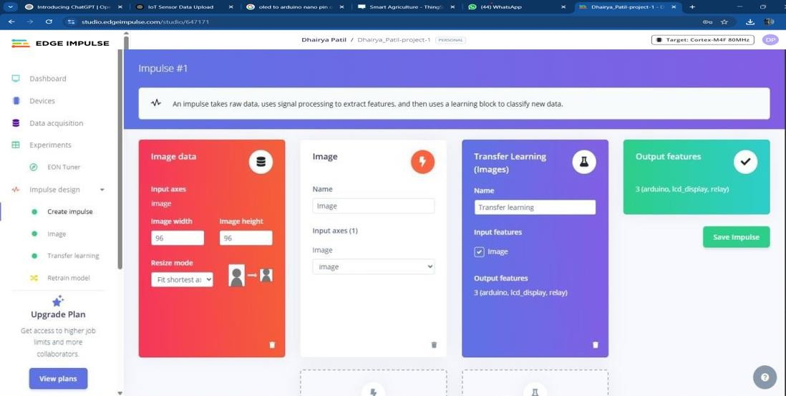**Dataset Image**
2. **Feature Extraction Image**

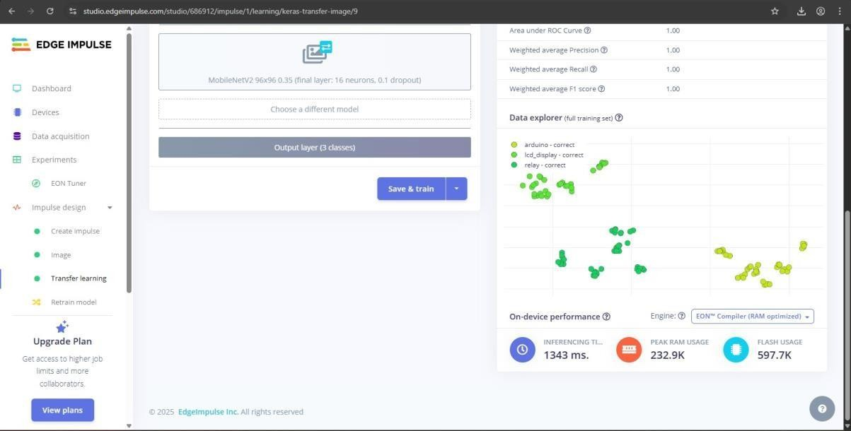

1. 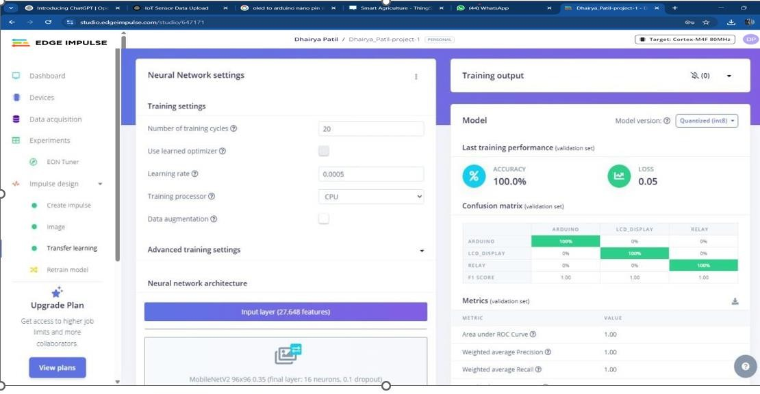**Accuracy / Loss Confusion Matrix Image**
   1. Copy of the Arduino Code

/* Edge Impulse ingestion SDK

* + - Copyright © 2022 EdgeImpulse Inc.

*

* + - Licensed under the Apache License, Version 2.0 (the “License”);
    - you may not use this file except in compliance with the License.
    - You may obtain a copy of the License at
    - <http://www.apache.org/licenses/LICENSE-2.0>
    - Unless required by applicable law or agreed to in writing, software
    - distributed under the License is distributed on an “AS IS” BASIS,
    - WITHOUT WARRANTIES OR CONDITIONS OF ANY KIND, either express or implied.
    - See the License for the specific language governing permissions and
    - limitations under the License.

*/

/* Includes */

#include <camera_inferencing.h>

#include <Arduino_OV767X.h> //Click here to get the library: <https://www.arduino.cc/reference/en/libraries/arduino_ov767x/>

|  |  |
| --- | --- |
| #include <stdint.h>  #include <stdlib.h> |  |
| /* Constant variables  #define EI_CAMERA_RAW_FRAME_BUFFER_COLS | */ |
| 160 |
| #define EI_CAMERA_RAW_FRAME_BUFFER_ROWS | 120 |

#define DWORD_ALIGN_PTR(a) ((a & 0x3) ?(((uintptr_t)a + 0x4) & ~(uintptr_t)0x3) : a)

/*

** NOTE: If you run into TFLite arena allocation issue.

**

** This may be due to may dynamic memory fragmentation.

** Try defining “-DEI_CLASSIFIER_ALLOCATION_STATIC” in boards.local.txt (create

** if it doesn’t exist) and copy this file to

** `<ARDUINO_CORE_INSTALL_PATH>/arduino/hardware/<mbed_core>/<core_version>/`.

**

** See

** ([https://support.arduino.cc/hc/en-us/articles/360012076960-Where-are-the-installed-cores-](https://support.arduino.cc/hc/en-us/articles/360012076960-Where-are-the-installed-cores-located-) [located-](https://support.arduino.cc/hc/en-us/articles/360012076960-Where-are-the-installed-cores-located-))

** to find where Arduino installs cores on your machine.

**

** If the problem persists then there’s not enough memory for this model and application.

*/

/* Edge Impulse */

Class OV7675 : public OV767X { Public:

Int begin(int resolution, int format, int fps); Void readFrame(void* buffer);

Private:

Int vsyncPin; Int hrefPin; Int pclkPin; Int xclkPin;

Volatile uint32_t* vsyncPort; Uint32_t vsyncMask; Volatile uint32_t* hrefPort; Uint32_t hrefMask;

Volatile uint32_t* pclkPort; Uint32_t pclkMask;

Uint16_t width; Uint16_t height;

Uint8_t bytes_per_pixel;

Uint16_t bytes_per_row;

Uint8_t buf_rows;

Uint16_t buf_size;

Uint8_t resize_height;

Uint8_t *raw_buf;

Void *buf_mem; Uint8_t *intrp_buf; Uint8_t *buf_limit;

Void readBuf();

Int allocate_scratch_buffs(); Int deallocate_scratch_buffs();

};

Typedef struct {

Size_t width; Size_t height;

} ei_device_resize_resolutions_t;

/**

* + - @brief Check if new serial data is available
    - @return Returns number of available bytes

*/

Int ei_get_serial_available(void) { Return Serial.available();

}

/**

* + - @brief Get next available byte
    - @return byte

*/

Char ei_get_serial_byte(void) { Return Serial.read();

}

/* Private variables */

Static OV7675 Cam;

Static bool is_initialised = false;

/*

** @brief points to the output of the capture

*/

Static uint8_t *ei_camera_capture_out = NULL; Uint32_t resize_col_sz;

Uint32_t resize_row_sz; Bool do_resize = false; Bool do_crop = false;

Static bool debug_nn = false; // Set this to true to see e.g. features generated from the raw signal

/* Function definitions */

Bool ei_camera_init(void); Void ei_camera_deinit(void);

Bool ei_camera_capture(uint32_t img_width, uint32_t img_height, uint8_t *out_buf) ;

Int calculate_resize_dimensions(uint32_t out_width, uint32_t out_height, uint32_t *resize_col_sz, uint32_t *resize_row_sz, bool *do_resize);

Void resizeImage(int srcWidth, int srcHeight, uint8_t *srcImage, int dstWidth, int dstHeight, uint8_t

*dstImage, int iBpp);

Void cropImage(int srcWidth, int srcHeight, uint8_t *srcImage, int startX, int startY, int dstWidth, int dstHeight, uint8_t *dstImage, int iBpp);

/**

* + - @brief Arduino setup function

*/

Void setup()

{

// put your setup code here, to run once:

Serial.begin(115200);

// comment out the below line to cancel the wait for USB connection (needed for native USB)

While (!Serial);

Serial.println(“Edge Impulse Inferencing Demo”);

// summary of inferencing settings (from model_metadata.h)

Ei_printf(“Inferencing settings:\n”);

Ei_printf(“\tImage resolution: %dx%d\n”, EI_CLASSIFIER_INPUT_WIDTH,

EI_CLASSIFIER_INPUT_HEIGHT);

Ei_printf(“\tFrame size: %d\n”, EI_CLASSIFIER_DSP_INPUT_FRAME_SIZE);

Ei_printf(“\tNo. Of classes: %d\n”, sizeof(ei_classifier_inferencing_categories) /

sizeof(ei_classifier_inferencing_categories[0]));

}

/**

* + - @brief Get data and run inferencing
    - @param[in] debug Get debug info if true

*/

Void loop()

{

Bool stop_inferencing = false;

While(stop_inferencing == false) {

Ei_printf(“\nStarting inferencing in 2 seconds…\n”);

// instead of wait_ms, we’ll wait on the signal, this allows threads to cancel us…

If (ei_sleep(2000) != EI_IMPULSE_OK) { Break;

}

Ei_printf(“Taking photo…\n”);

If (ei_camera_init() == false) {

Ei_printf(“ERR: Failed to initialize image sensor\r\n”); Break;

}

// choose resize dimensions Uint32_t resize_col_sz; Uint32_t resize_row_sz; Bool do_resize = false;

Int res = calculate_resize_dimensions(EI_CLASSIFIER_INPUT_WIDTH, EI_CLASSIFIER_INPUT_HEIGHT, &resize_col_sz, &resize_row_sz, &do_resize);

If (res) {

Ei_printf(“ERR: Failed to calculate resize dimensions (%d)\r\n”, res); Break;

}

Void *snapshot_mem = NULL; Uint8_t *snapshot_buf = NULL;

Snapshot_mem = ei_malloc(resize_col_sz*resize_row_sz*2); If(snapshot_mem == NULL) {

Ei_printf(“failed to create snapshot_mem\r\n”); Break;

}

Snapshot_buf = (uint8_t *)DWORD_ALIGN_PTR((uintptr_t)snapshot_mem);

If (ei_camera_capture(EI_CLASSIFIER_INPUT_WIDTH, EI_CLASSIFIER_INPUT_HEIGHT, snapshot_buf) == false) {

Ei_printf(“Failed to capture image\r\n”);

If (snapshot_mem) ei_free(snapshot_mem); Break;

}

Ei::signal_t signal;

Signal.total_length = EI_CLASSIFIER_INPUT_WIDTH * EI_CLASSIFIER_INPUT_HEIGHT; Signal.get_data = &ei_camera_cutout_get_data;

// run the impulse: DSP, neural network and the Anomaly algorithm Ei_impulse_result_t result = { 0 };

EI_IMPULSE_ERROR ei_error = run_classifier(&signal, &result, debug_nn); If (ei_error != EI_IMPULSE_OK) {

Ei_printf(“Failed to run impulse (%d)\n”, ei_error); Ei_free(snapshot_mem);

Break;

}

// print the predictions

Ei_printf(“Predictions (DSP: %d ms., Classification: %d ms., Anomaly: %d ms.): \n”, Result.timing.dsp, result.timing.classification, result.timing.anomaly);

#if EI_CLASSIFIER_OBJECT_DETECTION == 1

Ei_printf(“Object detection bounding boxes:\r\n”);

For (uint32_t I = 0; I < result.bounding_boxes_count; i++) { Ei_impulse_result_bounding_box_t bb = result.bounding_boxes[i]; If (bb.value == 0) {

Continue;

}

Ei_printf(“ %s (%f) [ x: %u, y: %u, width: %u, height: %u ]\r\n”, bb.label,

bb.value, bb.x,

bb.y, bb.width, bb.height);

}

// Print the prediction results (classification) #else

Ei_printf(“Predictions:\r\n”);

For (uint16_t I = 0; I < EI_CLASSIFIER_LABEL_COUNT; i++) {

Ei_printf(“ %s: “, ei_classifier_inferencing_categories[i]);

Ei_printf(“%.5f\r\n”, result.classification[i].value);

}

#endif

// Print anomaly result (if it exists) #if EI_CLASSIFIER_HAS_ANOMALY

Ei_printf(“Anomaly prediction: %.3f\r\n”, result.anomaly);

#endif

#if EI_CLASSIFIER_HAS_VISUAL_ANOMALY

Ei_printf(“Visual anomalies:\r\n”);

For (uint32_t I = 0; I < result.visual_ad_count; i++) { Ei_impulse_result_bounding_box_t bb = result.visual_ad_grid_cells[i]; If (bb.value == 0) {

Continue;

}

Ei_printf(“ %s (%f) [ x: %u, y: %u, width: %u, height: %u ]\r\n”, bb.label,

bb.value, bb.x,

bb.y, bb.width, bb.height);

}

#endif

While (ei_get_serial_available() > 0) {

If (ei_get_serial_byte() == ‘b’) {

Ei_printf(“Inferencing stopped by user\r\n”); Stop_inferencing = true;

}

}

If (snapshot_mem) ei_free(snapshot_mem);

}

Ei_camera_deinit();

}

/**

* + - @brief Determine whether to resize and to which dimension
    - @param[in] out_width width of output image
    - @param[in] out_height height of output image
    - @param[out] resize_col_sz pointer to frame buffer’s column/width value
    - @param[out] resize_row_sz pointer to frame buffer’s rows/height value
    - @param[out] do_resize returns whether to resize (or not)

*/

Int calculate_resize_dimensions(uint32_t out_width, uint32_t out_height, uint32_t *resize_col_sz, uint32_t *resize_row_sz, bool *do_resize)

{

Size_t list_size = 2;

Const ei_device_resize_resolutions_t list[list_size] = { {42,32}, {128,96} };

// (default) conditions

*resize_col_sz = EI_CAMERA_RAW_FRAME_BUFFER_COLS;

*resize_row_sz = EI_CAMERA_RAW_FRAME_BUFFER_ROWS;

*do_resize = false;

For (size_t ix = 0; ix < list_size; ix++) {

If ((out_width <= list[ix].width) && (out_height <= list[ix].height)) {

*resize_col_sz = list[ix].width;

*resize_row_sz = list[ix].height;

*do_resize = true; Break;

}

}

Return 0;

}

/**

* + - @brief Setup image sensor & start streaming
    - @retval false if initialisation failed

*/

Bool ei_camera_init(void) {

If (is_initialised) return true;

If (!Cam.begin(QQVGA, RGB565, 1)) { // VGA downsampled to QQVGA (OV7675)

Ei_printf(“ERR: Failed to initialize camera\r\n”);

Return false;

}

Is_initialised = true;

Return true;

}

/**

* + - @brief Stop streaming of sensor data

*/

Void ei_camera_deinit(void) { If (is_initialised) {

Cam.end(); Is_initialised = false;

}

}

/**

* + - @brief Capture, rescale and crop image
    - @param[in] img_width width of output image
    - @param[in] img_height height of output image
    - @param[in] out_buf pointer to store output image, NULL may be used
    - when full resolution is expected.
    - @retval false if not initialised, image captured, rescaled or cropped failed

*/

Bool ei_camera_capture(uint32_t img_width, uint32_t img_height, uint8_t *out_buf)

{

If (!is_initialised) {

Ei_printf(“ERR: Camera is not initialized\r\n”); Return false;

}

If (!out_buf) {

Ei_printf(“ERR: invalid parameters\r\n”);

Return false;

}

// choose resize dimensions

Int res = calculate_resize_dimensions(img_width, img_height, &resize_col_sz, &resize_row_sz, &do_resize);

If (res) {

Ei_printf(“ERR: Failed to calculate resize dimensions (%d)\r\n”, res); Return false;

}

If ((img_width != resize_col_sz)

|| (img_height != resize_row_sz)) { Do_crop = true;

}

Cam.readFrame(out_buf); // captures image and resizes

If (do_crop) {

Uint32_t crop_col_sz; Uint32_t crop_row_sz; Uint32_t crop_col_start; Uint32_t crop_row_start;

Crop_row_start = (resize_row_sz – img_height) / 2; Crop_col_start = (resize_col_sz – img_width) / 2; Crop_col_sz = img_width;

Crop_row_sz = img_height;

//ei_printf(“crop cols: %d, rows: %d\r\n”, crop_col_sz,crop_row_sz);

cropImage(resize_col_sz, resize_row_sz, out_buf,

crop_col_start, crop_row_start,

crop_col_sz, crop_row_sz, out_buf,

16);

}

// The following variables should always be assigned

// if this routine is to return true

// cutout values

//ei_camera_snapshot_is_resized = do_resize;

//ei_camera_snapshot_is_cropped = do_crop; Ei_camera_capture_out = out_buf;

Return true;

}

/**

* + - @brief Convert RGB565 raw camera buffer to RGB888
    - @param[in] offset pixel offset of raw buffer
    - @param[in] length number of pixels to convert
    - @param[out] out_buf pointer to store output image

*/

Int ei_camera_cutout_get_data(size_t offset, size_t length, float *out_ptr) { Size_t pixel_ix = offset * 2;

Size_t bytes_left = length;

Size_t out_ptr_ix = 0;

// read byte for byte While (bytes_left != 0) {

// grab the value and convert to r/g/b

Uint16_t pixel = (ei_camera_capture_out[pixel_ix] << 8) | ei_camera_capture_out[pixel_ix+1]; Uint8_t r, g, b;

R = ((pixel >> 11) & 0x1f) << 3; G = ((pixel >> 5) & 0x3f) << 2; B = (pixel & 0x1f) << 3;

// then convert to out_ptr format Float pixel_f = (r << 16) + (g << 8) + b; Out_ptr[out_ptr_ix] = pixel_f;

// and go to the next pixel Out_ptr_ix++; Pixel_ix+=2;

Bytes_left--;

}

// and done! Return 0;

}

// This include file works in the Arduino environment

// to define the Cortex-M intrinsics #ifdef _ ARM_FEATURE_SIMD32 #include <device.h>

#endif

// This needs to be < 16 or it won’t fit. Cortex-M4 only has SIMD for signed multiplies #define FRAC_BITS 14

#define FRAC_VAL (1<<FRAC_BITS) #define FRAC_MASK (FRAC_VAL – 1)

//

// Resize

//

// Assumes that the destination buffer is dword-aligned

// Can be used to resize the image smaller or larger

// If resizing much smaller than 1/3 size, then a more rubust algorithm should average all of the pixels

// This algorithm uses bilinear interpolation – averages a 2x2 region to generate each new pixel

//

// Optimized for 32-bit MCUs

// supports 8 and 16-bit pixels

Void resizeImage(int srcWidth, int srcHeight, uint8_t *srcImage, int dstWidth, int dstHeight, uint8_t

*dstImage, int iBpp)

{

Uint32_t src_x_accum, src_y_accum; // accumulators and fractions for scaling the image Uint32_t x_frac, nx_frac, y_frac, ny_frac;

Int x, y, ty, tx;

If (iBpp != 8 && iBpp != 16) Return;

Src_y_accum = FRAC_VAL/2; // start at ½ pixel in to account for integer downsampling which might miss pixels

Const uint32_t src_x_frac = (srcWidth * FRAC_VAL) / dstWidth; Const uint32_t src_y_frac = (srcHeight * FRAC_VAL) / dstHeight; Const uint32_t r_mask = 0xf800f800;

Const uint32_t g_mask = 0x07e007e0; Const uint32_t b_mask = 0x001f001f; Uint8_t *s, *d;

Uint16_t *s16, *d16;

Uint32_t x_frac2, y_frac2; // for 16-bit SIMD For (y=0; y < dstHeight; y++) {

Ty = src_y_accum >> FRAC_BITS; // src y Y_frac = src_y_accum & FRAC_MASK; Src_y_accum += src_y_frac;

Ny_frac = FRAC_VAL – y_frac; // y fraction and 1.0 – y fraction Y_frac2 = ny_frac | (y_frac << 16); // for M4/M4 SIMD

S = &srcImage[ty * srcWidth];

S16 = (uint16_t *)&srcImage[ty * srcWidth * 2]; D = &dstImage[y * dstWidth];

D16 = (uint16_t *)&dstImage[y * dstWidth * 2];

Src_x_accum = FRAC_VAL/2; // start at ½ pixel in to account for integer downsampling which might miss pixels

If (iBpp == 8) {

For (x=0; x < dstWidth; x++) { Uint32_t tx, p00,p01,p10,p11; Tx = src_x_accum >> FRAC_BITS;

X_frac = src_x_accum & FRAC_MASK;

Nx_frac = FRAC_VAL – x_frac; // x fraction and 1.0 – x fraction X_frac2 = nx_frac | (x_frac << 16);

Src_x_accum += src_x_frac; P00 = s[tx]; p10 = s[tx+1];

P01 = s[tx+srcWidth]; p11 = s[tx+srcWidth+1]; #ifdef ARM_FEATURE_SIMD32

P00 = SMLAD(p00 | (p10<<16), x_frac2, FRAC_VAL/2) >> FRAC_BITS; // top line P01 = SMLAD(p01 | (p11<<16), x_frac2, FRAC_VAL/2) >> FRAC_BITS; // bottom line P00 = SMLAD(p00 | (p01<<16), y_frac2, FRAC_VAL/2) >> FRAC_BITS; // combine

#else // generic C code

P00 = ((p00 * nx_frac) + (p10 * x_frac) + FRAC_VAL/2) >> FRAC_BITS; // top line P01 = ((p01 * nx_frac) + (p11 * x_frac) + FRAC_VAL/2) >> FRAC_BITS; // bottom line

P00 = ((p00 * ny_frac) + (p01 * y_frac) + FRAC_VAL/2) >> FRAC_BITS; // combine top + bottom #endif // Cortex-M4/M7

*d++ = (uint8_t)p00; // store new pixel

} // for x

} // 8-bpp Else

{ // RGB565

For (x=0; x < dstWidth; x++) {

Uint32_t tx, p00,p01,p10,p11;

Uint32_t r00, r01, r10, r11, g00, g01, g10, g11, b00, b01, b10, b11; Tx = src_x_accum >> FRAC_BITS;

X_frac = src_x_accum & FRAC_MASK;

Nx_frac = FRAC_VAL – x_frac; // x fraction and 1.0 – x fraction X_frac2 = nx_frac | (x_frac << 16);

Src_x_accum += src_x_frac;

P00 = builtin_bswap16(s16[tx]); p10 = builtin_bswap16(s16[tx+1]);

P01 = builtin_bswap16(s16[tx+srcWidth]); p11 = builtin_bswap16(s16[tx+srcWidth+1]); #ifdef ARM_FEATURE_SIMD32

{

P00 |= (p10 << 16); P01 |= (p11 << 16);

R00 = (p00 & r_mask) >> 1; g00 = p00 & g_mask; b00 = p00 & b_mask; R01 = (p01 & r_mask) >> 1; g01 = p01 & g_mask; b01 = p01 & b_mask; R00 = SMLAD(r00, x_frac2, FRAC_VAL/2) >> FRAC_BITS; // top line R01 = SMLAD(r01, x_frac2, FRAC_VAL/2) >> FRAC_BITS; // bottom line

R00 = SMLAD(r00 | (r01<<16), y_frac2, FRAC_VAL/2) >> FRAC_BITS; // combine G00 = SMLAD(g00, x_frac2, FRAC_VAL/2) >> FRAC_BITS; // top line

G01 = SMLAD(g01, x_frac2, FRAC_VAL/2) >> FRAC_BITS; // bottom line

G00 = SMLAD(g00 | (g01<<16), y_frac2, FRAC_VAL/2) >> FRAC_BITS; // combine B00 = SMLAD(b00, x_frac2, FRAC_VAL/2) >> FRAC_BITS; // top line

B01 = SMLAD(b01, x_frac2, FRAC_VAL/2) >> FRAC_BITS; // bottom line

B00 = SMLAD(b00 | (b01<<16), y_frac2, FRAC_VAL/2) >> FRAC_BITS; // combine

}

#else // generic C code

{

R00 = (p00 & r_mask) >> 1; g00 = p00 & g_mask; b00 = p00 & b_mask; R10 = (p10 & r_mask) >> 1; g10 = p10 & g_mask; b10 = p10 & b_mask; R01 = (p01 & r_mask) >> 1; g01 = p01 & g_mask; b01 = p01 & b_mask; R11 = (p11 & r_mask) >> 1; g11 = p11 & g_mask; b11 = p11 & b_mask;

R00 = ((r00 * nx_frac) + (r10 * x_frac) + FRAC_VAL/2) >> FRAC_BITS; // top line R01 = ((r01 * nx_frac) + (r11 * x_frac) + FRAC_VAL/2) >> FRAC_BITS; // bottom line

R00 = ((r00 * ny_frac) + (r01 * y_frac) + FRAC_VAL/2) >> FRAC_BITS; // combine top + bottom G00 = ((g00 * nx_frac) + (g10 * x_frac) + FRAC_VAL/2) >> FRAC_BITS; // top line

G01 = ((g01 * nx_frac) + (g11 * x_frac) + FRAC_VAL/2) >> FRAC_BITS; // bottom line

G00 = ((g00 * ny_frac) + (g01 * y_frac) + FRAC_VAL/2) >> FRAC_BITS; // combine top + bottom B00 = ((b00 * nx_frac) + (b10 * x_frac) + FRAC_VAL/2) >> FRAC_BITS; // top line

B01 = ((b01 * nx_frac) + (b11 * x_frac) + FRAC_VAL/2) >> FRAC_BITS; // bottom line B00 = ((b00 * ny_f

* 1. **Output**

